**MINI PROJECT** -2

**(2020-21)**

### Build and Deploy a Web Application for Student Management System using PHP.

**MID-TERM REPORT**



**Institute of Engineering & Technology**

**Submitted by-**

**Aditya Pandey**

**(181500043)**

**Mukul Joshi**

**(181500399)**

**Devansh Pandey**

**(181500212)**

***Supervised By: -***

### Ms. Priya Agarwal

Technical Trainer

### Department of Computer Engineering & Applications

### Contents

**Abstract**

1. Introduction
   1. General Introduction to the topic.
   2. Area of computer science.
   3. Hardware and Software requirements.
   4. Problem Definition
   5. Objectives
   6. Screenshot
   7. References

## Abstract

This project **“Student Management System”** provides us a simple interface for maintenance of student information. It can be used by educational institutes or colleges to maintain the records of students easily. Achieving this objective is difficult using a manual system as the information is scattered, can be redundant and collecting relevant information may be very time consuming. All these problems are solved using this project.

Throughout the project the focus has been on presenting information in an easy and intelligible manner. The project is very useful for those who want to know about Student Management System and want to develop software /websites based on the same concept.

The project provides facilities like online registration and profile creation of students thus reducing paperwork and automating the record generation process in an educational institution.

## Introduction

### General Introduction to the topic

Student Information Management System can be used by education institutes to maintain the records of students easily. Achieving this objective is difficult using a manual system as the information is scattered, can be redundant and collecting relevant information may be very time consuming. All these problems are solved using this project.

**1.2 Area of Computer Science**  The area of computer science in web development has some pretty cool applications and is heavily used in developing websites android web applications, etc. For example, a very popular website Amazon.com that uses JavaScript within webpages as scripting language.

* 1. **Hardware requirements**

**Recommended Operating Systems**

* **Windows:**7 or newer

**Hardware Requirements**

* Processor: Minimum 1 GHz; Recommended 2GHz or more
* Ethernet connection (LAN) OR a wireless adapter (Wi-Fi)
* Hard Drive: Minimum 32 GB; Recommended 64 GB or more
* Memory (RAM): Minimum 1 GB; Recommended 4 GB or above
* Graphics card: Minimum 256mb or above

#### 1.4 Software requirements

* WAMP/XAMP Server are used.
* Any Text Editor like Sublime/Notepad++ etc. are used.
* Browser: chrome v90.0.4430.93, Firefox v88.0

**Problem Definition**: some of the intuition/schools can’t keep the track of data which result in degradation in marks of students.

There is huge difficulty in managing lots of student data in their respective database.

**Objective**

In this project, we are going to make a website where students can log in to our site through their respective username & password. The main objective of the Student Management System is to manage the details of Profiles, Courses, Logins, Exams, Fees. It manages all the information about Profiles, Student, Fees, Profiles. The project is totally built at administrative end and thus only the administrator is guaranteed the access.

# SCREENSHOTS

–––––-–––––

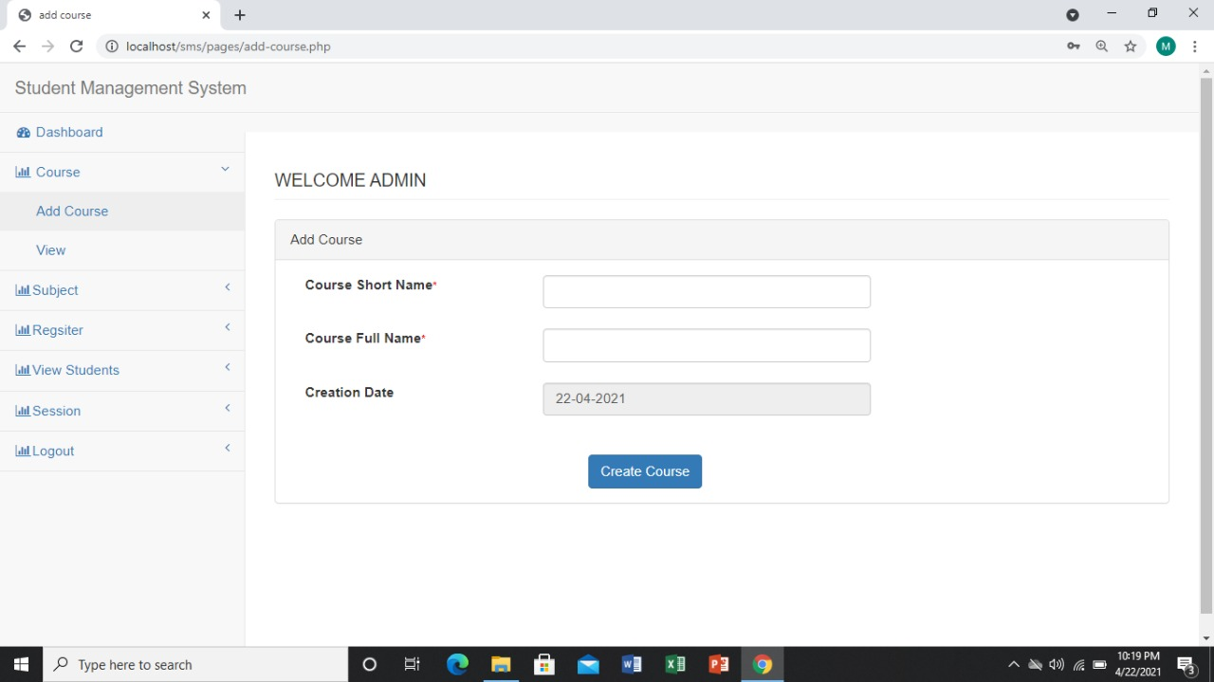

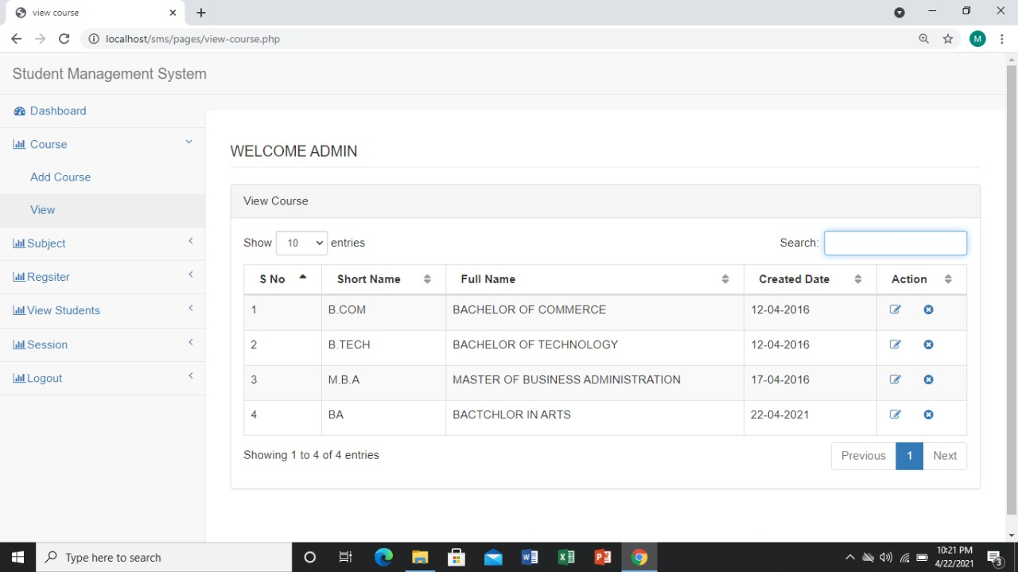

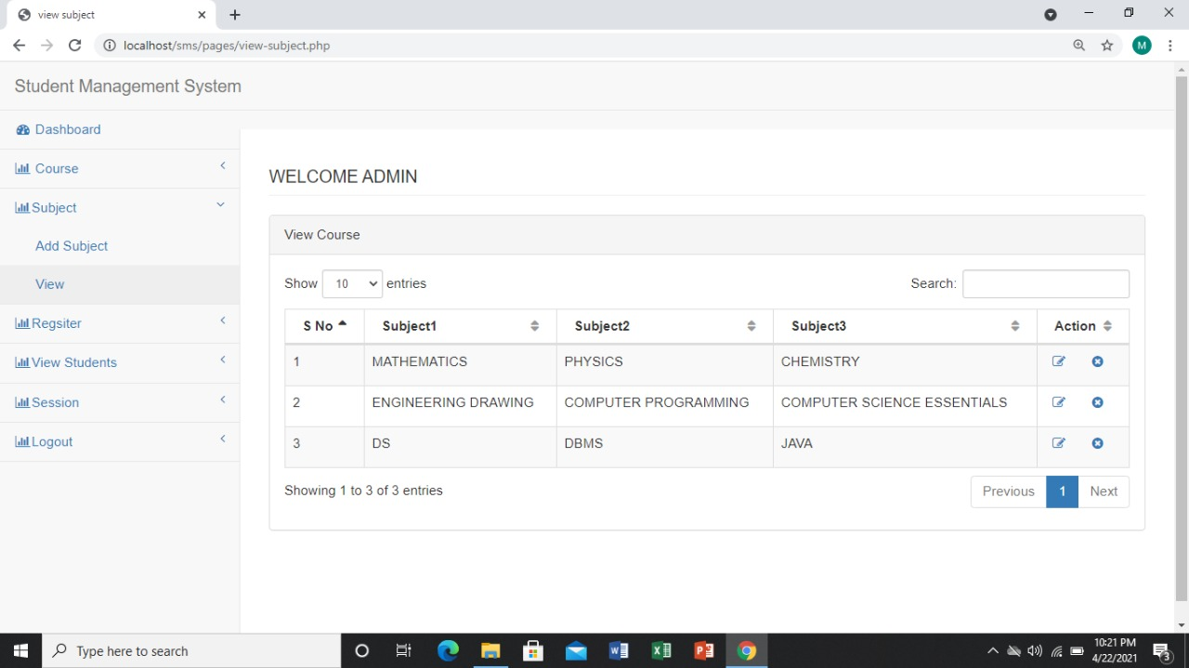

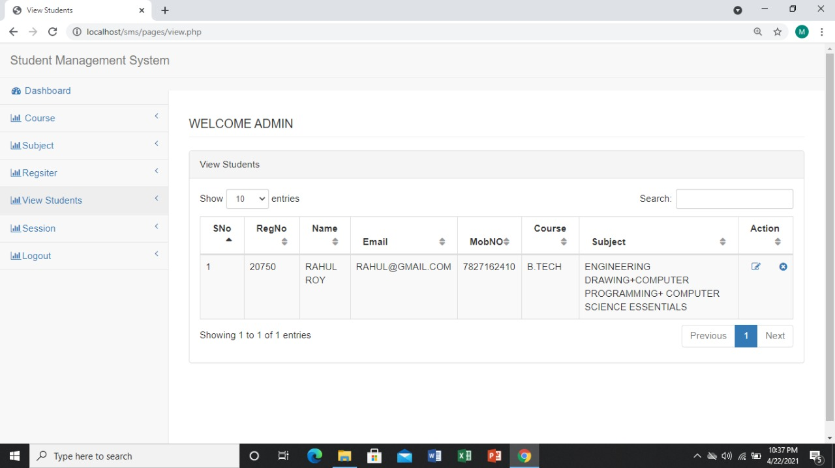

**REFERENCES**

[www.google.com](http://www.google.com)